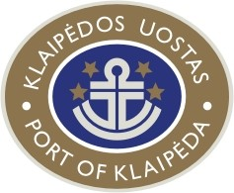

KLAIPEDA STATE SEAPORT AUTHORITY

WORKSHOP (WS 04-17)

PASSENGER TRAFFIC TRENDS IN THE EU –
ESPECIALLY CRUISE WITHIN THE BALTIC RANGE

22 – 25 MAY, 2007,
KLAIPEDA

WORKSHOP MANUAL

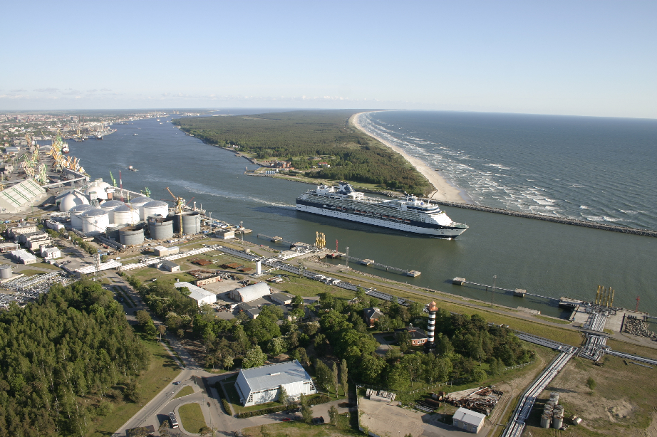

TUESDAY, 22 MAY, 2007

16⁰⁰  18⁰⁰ – 18³⁰  18³⁰ – 19³⁰ | Transfer from Palanga Airport to the Hotel  Participants arriving from Copenhagen at 15.10 or 23.55 hrs  Participants arriving from Amsterdam at 16.05 hrs  Participants arriving from Tallinn at 09.50 hrs  Registration of the delegates.  Hotel EUROPA ROYALE KLAIPEDA,  Žvejų str. 21 / Teatro str. 1 (www.hoteleuropa.lt).  Distribution of delegate information material and badges.  KLAIPEDA CITY WALK - guided tour (English)
19³⁰ – 21⁰⁰ | Informal reception at Klaipeda Hotel K Centre XX floor restaurant VIVALAVITA with the panoramic view to the port and city (www.klaipedahotel.lt)  (Address: Naujoji sodo str. 1a, 20th floor)

WEDNESDAY , 23 MAY, 2007
Conference hall at Pramogu bankas (Entertainment Bank)
IV floor (Turgaus street 1)

8⁰⁰  9⁰⁰ – 9¹⁵  9¹⁵ – 9³⁵  9³⁵ – 9⁵⁵  9⁵⁵ – 10¹⁵  10¹⁵ – 10³⁵  10³⁵ – 10⁵⁵ | Visiting the Official welcoming ceremony for cruise vessel Constellation  at Cruise Vessel Terminal (optional, from Hotel EUROPA ROYALE)  Welcoming addresses:  Mr. Rimantas Taraškevičius, Mayor of Klaipėda City.  Mr. Sigitas Dobilinskas, Director General, Klaipėda State Seaport  Authority (Lithuania) on behalf of Mr. Algirdas Butkevičius, Minister  of Transport and Communications of the Republic of Lithuania  Investment Climate in Lithuania  Ms. Laimutė Kalinauskienė, Director of Investment and Innovations Department, Ministry of Economy of the Republic of Lithuania  Tourism Development in Lithuania  Ms. Nijolė Kliokienė, Deputy Director of State Tourism Department  under the Ministry of Economy of the Republic of Lithuania  The Port of Klaipeda – Development and Perspectives  Mr. Sigitas Dobilinskas, Director General,  Klaipėda State Seaport Authority (Lithuania)  World Cruise Tourism Market and the Baltic Vision. Port  Operations and Infrastructure Needs  Mr. Peter Wild, Director, G.P.Wild (International) Ltd. (UK)  Discovering the Baltics – an American Perspective to Cruise  Shipping in North Europe  Cpt. Ioannis Papanikolaou, Master of GTS CONSTELLATION, CELEBRITY CRUISE LINE (USA)
10⁵⁵ – 11²⁵ | Coffee break  Press Conference
11²⁵ – 12⁴⁵ | Port tour by boat (coffee and snacks on board)  Visiting Cruise Vessel Terminal
12⁴⁵ – 13⁰⁰ | Departure to the restaurant
13⁰⁰ – 14⁰⁰ | Lunch at the restaurant RELAX in Pramogu bankas (Entertainment Bank) ground floor (Turgaus street 1)
14⁰⁰ - 14²⁰ | Cruise Experience in Tallinn  Ms. Tiina Liitmae, Marketing Manager, The Port of Tallinn (Estonia)
14²⁰ – 14⁴⁰ | Cruise Experience in Malta  Mr. Jason Bongailas, Research and Development Manager,  Malta Maritime Authority (Malta)
14⁴⁰ – 15⁰⁰ | Cruise Shipping Studies and Expected Results  Mr. Alberto Cappato, IIC-Istituto Internazionale delle Comunicazioni, (Italy)  Mr. Ignas Zokas, Director, Spinter Research Ltd., (Lithuania)
15⁰⁰ – 15²⁰ | Development of Cruise Business in Klaipeda  Ms. Romena Savickienė, Director, Klaipėda Tourism and Culture Information Center, Klaipėda Municipality (Lithuania)
15²⁰ – 15³⁰ | DISCUSSIONS. CONCLUSIONS
15³⁰ – 15⁴⁵ | Coffee and snacks at the conference venue
16¹⁵ – 21⁰⁰ | Excursion to Nida and Juodkrantė (Guided tour)  (Dinner at a restaurant in Nida)

THURSDAY, 24 MAY, 2007
Conference hall at Pramogu bankas (Entertainment Bank), IV floor (Turgaus str.1)

9³⁰ – 9⁵⁰ | Role of the Association in Boosting of Cruise Business  Mr. Per Schmidt, Vice Chairman, Cruise Europe Association
9⁵⁰ – 10¹⁰ | Use of Marketing Tools for Cruise Business development  Mr. Bo Nylandsted Larsen, Project director of  INTERREG III B Baltic Cruise Project
10¹⁰ – 10³⁰ | The Cruise Consumers’ View  Mr. William Gibbons, Director, Passenger Shipping Association
10³⁰ – 10⁵⁰ | Coffee break
10⁵⁰ – 11¹⁰ | Perspectives of Cruise Terminal Facilities in Klaipeda  Mr. Alvydas Butkus, Director General,  Klaipėdos Laivų Remontas AB (Klaipėda Shiprepair Yard)
11¹⁰ – 11³⁰ | New Cruise Infrastructure in the Port of Klaipeda in 2009  Mr. Benediktas Petrauskas, Director General,  Klaipėdos Keleivių ir Krovinių Terminalas UAB  (Klaipėda Passenger and Cargo Terminal)
11³⁰ – 13⁰⁰ | Lunch at the restaurant of EUROPA ROYALE KLAIPEDA
13⁰⁰ – 13²⁰ | Trends of Passenger Flows in Klaipeda port  Mr. Vytautas Kaunas, Commercial director, Stevedoring company  KLASCO
13²⁰ – 13⁴⁰ | Choice of Shore Excursions in Klaipėda  Ms. Migle Holliday, Managing Director,  Travel agency Meja Travel UAB
13⁴⁰ - 14⁰⁰ | Special Shore Excursions in Klaipėda  Mr. Marius Serapinas, Manager of Incoming Tourism Department, Travel agency Krantas Travel UAB
14⁰⁰ – 14²⁰ | DISCUSSIONS. CONCLUSIONS.
14²⁰ – 16³⁰ | Free time
16³⁰ – 19⁰⁰ | Excursion to Palanga including Amber Museum  or  Visiting the shopping mall “Akropolis”  (transfer Hotel –“Akropolis” – Hotel will be provided)
19⁰⁰ – 21⁰⁰ | Dinner at the restaurant PAS JUOZAPA (“At Joseph’s place”)  (approx. 25 km far from Klaipėda)  Lithuanian national dishes and folk music

FRIDAY, 25 MAY, 2007
Conference hall at EUROPA ROYALE HOTEL, 1st floor

9⁰⁰ – 10³⁰ | (Only for PortNet members)  WORK GROUP MEETING (WP2 and WP4)  Mr. Hans-Ulrich Wolff
10³⁰ – 13⁰⁰ | Excursion to Maritime Museum and Dolphinarium including Dolphin Show
13⁰⁰ – 14³⁰ | Lunch at local restaurant EUROPA ROYALE KLAIPEDA
14³⁰ | Departure to Palanga Airport  Participants departing to Copenhagen at 07.00 and 15.40 hrs  Participants departing to Tallinn at 17.40 hrs  Participants departing to Amsterdam at 10.30 hrs  Participants departing to Billund (Denmark) at 13.20 hrs

Contact person:

Klaipėda State Seaport Authority
Ms. Lina Gudelionytė Gylienė
Tel. +370 46 499 781,
Fax. +370 46 499625
cell +370 686 06116
e-mail: linag@port.lt
www.portofklaipeda.lt

PRACTICAL INFORMATION

Following information is a brief description of what you need to know before arriving.

KLAIPĖDA

Founded in 1252 on the coast of Baltic Sea, Klaipėda boasts rich history, deeply rooted traditions, distinct culture and beautiful nature. Third largest city in Lithuania Klaipėda city (pop. 188.8 thousand) is the northernmost ice-free port in the Baltic Sea and the only one in Lithuania. Klaipėda has been an important commercial centre since ancient times.

TRANSPORTATION

We recommend you to arrive in Palanga International Airport (www.palanga-airport.lt) which is 27 kilometres far from Klaipėda (located in the west part of Lithuania, near the Baltic Sea). You can fly in Palanga International Airport from Amsterdam, Copenhagen, Frankfurt (Main), Hamburg, Hanover, Tallinn. Klaipeda State Seaport Authority will provide you transfer: Palanga International Airport – Hotel “Europa Royale Klaipeda” (therefore, please, indicate precisely information from your Registration Form). www.europaroyale.com

Any questions regarding the travelling can be addressed to our travel agent Baltic Clipper, Ms Olga Drozdova, tel. +370 46 312 312.

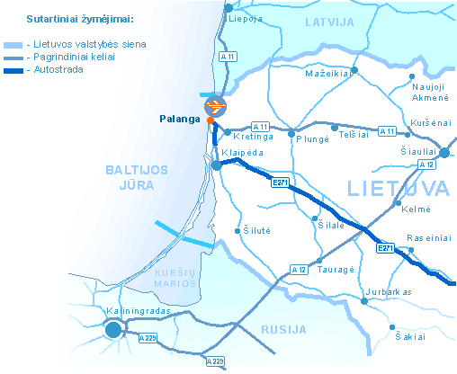

You can also choose to fly to Vilnius International Airport. It is, however, 300 km far from Klaipėda. Needful information about this Airport you can find in the website www.vilnius-airport.lt.

WORKSHOP VENUE

Conference be held in Pramogų Bankas conference hall IV floor
Turgaus street 1, Klaipėda

WORKING LANGUAGE

English

HOTEL INFORMATION
Deadline for registration 18 of May 2007

Address:
“Europa Royale“
Žvejų str. 21 / Teatro str. 1,
LT - 91247 Klaipėda, Lithuania
Tel: +370 46 40 44 44
Fax: +370 46 40 44 45
klaipeda@europaroyale.com
www.europaroyale.com

Price:
Single room 80,- Euro (breakfast included)
Double room 100,- Euro (breakfast included)

Contact person at the Hotel:
Front Office Manager
Mr. Arūnas Vaitiškis
Tel.: +370 46 404444

LIST OF SPEAKERS

No. | First name/last name | Company/association | Position | Country
I DAY, 23rd OF MAY, 2007
1. | Mr.Rimantas Taraškevičius | Klaipėda Municipality | Mayor of Klaipėda City | Lithuania
2. | Ms. Laimutė Kalinauskienė | Ministry of Economy of the Republic of Lithuania | Director of investment and innovations dept. | Lithuania
3. | Mr. Nijolė Kliokienė | State Tourism Department Ministry of Economy of the Republic of Lithuania | Deputy director | Lithuania
4. | Mr. Sigitas Dobilinskas | Klaipėda State Seaport Authority | Director General | Lithuania
5. | Mr. Peter Wild | G.P.Wild (International) Limited | Director | The UK
6. | Cpt. Ioannis Papanikolaou | Celebrity Cruise Line | Master of GTS Constellation | The USA
7. | Ms. Tiina Liitmae | Port of Tallinn | Marketing Manager | Estonia
8. | Mr. Jason Bongailas | Malta Maritime Authority | Research and Development Manager | Malta
9. | Mr. Alberto Cappato | IIC-Istituto Internazionale delle Comunicazioni | Market resercher | Italy
10. | Mr. Ignas Zokas | Spinter Research Ltd. | Director | Lithuania
11. | Ms Romena Savickiene | Klaipeda Tourism and Culture Information Centre | Director | Lithuania
II DAY, 24th OF MAY, 2007
12. | Mr. Per Schmidt | Cruise Europe Association | Vice Chairman | Denmark
13. | Mr. Bo Nylandsted Larsen | Baltic Cruise Project  (INTERREG III B) | Project Director | Denmark
14. | Mr. William Gibbons | Passenger Shipping Association | Director | The UK
15. | Mr. Alvydas Butkus | Klaipėdos Laivų Remontas AB (Klaipėda ship repair yard) | Director General | Lithuania
16. | Mr. Benediktas Petrauskas | Klaipėdos Keleivių ir Krovinių Terminalas UAB (Klaipėda passenger and cargo terminal) | Director General | Lithuania
17. | Mr.Vytautas Kaunas | Klaipeda Stevedoring Company KLASCO | Commercial director | Lithuania
18. | Ms Miglė Holliday | Travel agency Mėja Travel UAB | Managing Director | Lithuania
19. | Mr. Marius Serapinas | Travel agency Krantas Travel UAB | Manager of Incoming Tourism Department | Lithuania

LIST OF PARTICIPANTS AND GUESTS

No. | First name /last name | Company/association |  | Position | City
FOREIGN GUESTS
1. | Mr. Hans-Ulrich-Wolff | c/o Uniconsult,  Universal Transport Consulting GmbH |  | Director Central and Eastern European Countries | Germany
2. | Ms. Anna Ode | Hamburg Port Authority |  | Representative | Germany
3. | Dr. Matthias Ross | Hamburg Port Authority |  | Representative | Germany
4. | Mr. Jens Kristian Elvers | Hamburg Port Authority |  | Representative | Germany
5. | Mr. Michael Stange | Hamburg Ministry for Economy and Labour affairs |  | Representative | Germany
6. | Mr. Krzysztof Pilarski | Szczecin Port Authority |  | Representative | Szczecin
7. | Mr. Richard Morton | Haven Gateway Partnership |  | Project Manager | Colchester
8. | Mr. John Winn | Haven Gateway Partnership |  | Representative | Colchester
9. | Mr. Andrey Moshkov | “Rosmorport”, Kaliningrad Branch |  | Representative | Kaliningrad
10. | Ms. Tiina Liitmae | Port of Tallinn |  | Marketing Manager | Estonia
11. | Ms. Sirle Arro | Port of Tallinn |  | Representative | Tallinn
12. | Mr. Jason Bongailas | Malta Maritime Authority |  | Research and Development Manager | Malta
13. | Mr. Alberto Cappato | IIC-Istituto Internazionale delle Comunicazioni |  | Markert Resercher | Italy
14. | Mr. Gianni Borghi | Region Emilia – Romagna |  | Representative | Italy
15. | Mr. Karsten Brunings | Bremen Port Consult GmbH |  | Director | Germany
KLAIPĖDA STATE SEAPORT AUTHORITY (PARTNER’S STAFF)
1. | Mr. Sigitas Dobilinskas |  | Director General |  | Lithuania
2. | Mr. Viktoras Lukoševičius |  | Harbour Master |  | Lithuania
3. | Mr. Artūras Drungilas |  | Director of Marketing |  | Lithuania
4. | Mr. Algirdas Kamarauskas |  | Director for Infrastructure |  | Lithuania
5. | Mr. Algirdas Dulkė |  | Director for General Affairs |  | Lithuania
6. | Ms. Beata Kulevičiutė |  | Chief Financier |  | Lithuania
7. | Ms Lina Gudelionytė-Gylienė |  | Head of Marketing Department |  | Lithuania
8. | Mr. Linas Rudys |  | Head of Legal Department |  | Lithuania
9. | Mr. Julius Žilinskas |  | Marketing and International Relations Specialist |  | Lithuania
10. | Mr. Edvinas Kateiva |  | Market Research Analyst |  | Lithuania
11. | Ms. Geda Marozaitė |  | Marketing and International Relations Specialist |  | Lithuania
12. | Ms. Kristina Gontier |  | Public Relation Specialist |  | Lithuania

LOCAL GUESTS
1. | Ms. Romena Savickiene | Klaipeda Tourism and Culture Information Centre  Director
2. | Mr. Marius Serapinas | Travel agency Krantas Travel UAB, Manager of Incoming Tourism Department
3. | Mr. Alvydas Butkus | Klaipėda Shiprepair Yard  Director General
4. | Mr. Benediktas Petrauskas | Klaipėda Passenger and Cargo Terminal  Director General
5. | Ms Miglė Holliday | Travel agency Mėja Travel UAB  Managing Director
6. | Mr. Vytautas Kaunas | Klaipeda Stevedoring Company (KLASCO), AB  Director for Commerce
7. | Mr. Vytautas Rinkevičius | Klaipėda County  Chef of District
8. | Mr. Ričardas Zulcas | Klaipėda Municipality  Director of Economy and Strategy Department
9. | Mr. Aloyzas Každailevičius | Klaipėda Municipality  Director
10 | Ms. Elona Jurkevičienė | Klaipėda Municipality  Head of Investment and Business Development Division
11. | Mr. Liutauras Kraniauskas | Klaipėda Municipality  Head of International Relations and Tourism Division
12. | Ms. Nijolė Laužikienė | Klaipėda Municipality  Director of Social Department
13. | Ms. Goda Giedraitytė | Klaipėda Municipality  Head of Culture Division
14. | Ms. Ina Šidlauskienė | Klaipėda Municipality, Chief Expert of Head of International Relations and Tourism Division
15. | Ms. Diana Kateivaitė | UAB Relita  Director
16. | Mr. Genadij Šapkin | Klaipėda Shiprepair Yard  Agent
17. | Mr. Saulius Laumenis | UAB Limarko Jūrų Agentūra  Head of Forwarding Department
18. | Mr. Aloyzas Vilkas | UAB Gintarinė Įlanka  Director
19. | Mr. Vytautas Šileika | Association of Lithuanian Shipbrokers and Agents  President
20. | Mr. Saulius Laumenis | UAB „Limarko“ jūrų agentūra“  Manager Agency Department
21. | Mr. Viktor Budiak | Association of Lithuanian Stevedoring Companies  Director
22. | Mr. Gintautas Kutka | Association of Lithuanian Shipowners  Director
23. | Mr. Vidas Kuklierius | Klaipeda Stevedoring Company (KLASCO), AB  Marketing Department  Representative

NOTES

…………………………………………………………………………………………………………………………………………………………………………………………………………………………………………………………………………………………………………………………………………………………………………………………………………………………………………………………………………………………………………………………………………………………………………………………………………………………………………………………………………………………………………………………………………………………………………………………………………………………………………………………………………………………………………………………………………………………………………………………………………………………………………………………………………………………………………………………………………………………………………………………………………………………………………………………………………………………………………………………………………………………………………………………………………………………………………
…………………………………………………………………………………………………………………………………………………………………………………………………………………………………………………………………………………………………………………………………………………………………………………………………………………………………………………………………………………………………………………………………………………………………………………………………………………………………………………………………………………………………………………………………………………………………………………………………………………………………………………………………………………………………………………………………………………………………………………………………………………………………………………………………………………………………………………………………………………………………………………………………………………………………………………………………………………………………………………………………………………………………………………………………………………………………………
………………………………………………………………………………………………………………………………………………………………………………………………………………………………………………………………………………………………………………………………

NOTES

…………………………………………………………………………………………………………………………………………………………………………………………………………………………………………………………………………………………………………………………………………………………………………………………………………………………………………………………………………………………………………………………………………………………………………………………………………………………………………………………………………………………………………………………………………………………………………………………………………………………………………………………………………………………………………………………………………………………………………………………………………………………………………………………………………………………………………………………………………………………………………………………………………………………………………………………………………………………………………………………………………………………………………………………………………………………………………
…………………………………………………………………………………………………………………………………………………………………………………………………………………………………………………………………………………………………………………………………………………………………………………………………………………………………………………………………………………………………………………………………………………………………………………………………………………………………………………………………………………………………………………………………………………………………………………………………………………………………………………………………………………………………………………………………………………………………………………………………………………………………………………………………………………………………………………………………………………………………………………………………………………………………………………………………………………………………………………………………………………………………………………………………………………………………………
………………………………………………………………………………………………………………………………………………………………………………………………………………………………………………………………………………………………………………………………

NOTES

…………………………………………………………………………………………………………………………………………………………………………………………………………………………………………………………………………………………………………………………………………………………………………………………………………………………………………………………………………………………………………………………………………………………………………………………………………………………………………………………………………………………………………………………………………………………………………………………………………………………………………………………………………………………………………………………………………………………………………………………………………………………………………………………………………………………………………………………………………………………………………………………………………………………………………………………………………………………………………………………………………………………………………………………………………………………………………
…………………………………………………………………………………………………………………………………………………………………………………………………………………………………………………………………………………………………………………………………………………………………………………………………………………………………………………………………………………………………………………………………………………………………………………………………………………………………………………………………………………………………………………………………………………………………………………………………………………………………………………………………………………………………………………………………………………………………………………………………………………………………………………………………………………………………………………………………………………………………………………………………………………………………………………………………………………………………………………………………………………………………………………………………………………………………………
………………………………………………………………………………………………………………………………………………………………………………………………………………………………………………………………………………………………………………………………

